1. Software Environment Description.

This tool is developed using Python 2.7.3 and PyQt4. To compile this project, you need to setup the environment as below:

1. Install Python 2.7.x for Windows

Download Python 2.7.x version for Windows and install into your computer.

<https://www.python.org/downloads/>

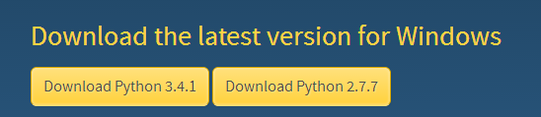

2. Install Python 2.7.x Excel package. This Library is used for generate the test report.

<http://www.python-excel.org/>

3. Install the Python Install. This tool is for generating a executable file for the computer which hasn’t install Python environment.

<http://www.pyinstaller.org/>

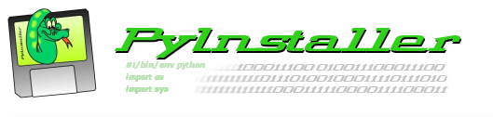

4. Install the Python Serial Port Library to access the Serial Port

<http://pyserial.sourceforge.net/>

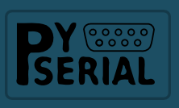

5. Install the PyQt for Python 2.7.x from Riverbank.

<http://www.riverbankcomputing.co.uk/software/pyqt/download>



6. Install the Eric4 IDE.

<http://eric-ide.python-projects.org/>

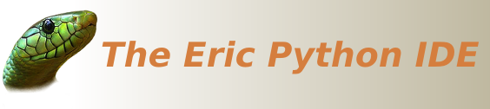

After install all the tools above, you have basically setup the Python 2.7.x GUI design environment for Qt4.

2. VayaMfgTool Introduction

Vaya Manufacturing Tool is used for configuring the Vaya Fixture with proper UID and Model Description, Discover and Fixture Test.